System Design

“A system is a collection of elements or components that are organized for a common purpose to carry out specific activity, perform a duty or solve a problem”.
Systems design is the process or art of defining the architecture, components, modules, interfaces, and data for a system to satisfy specified requirements.

3.1 Introduction

In previous chapter, we studied the existing system of recruitment and after studying this; we conclude that working in the existing system is overburdened for the staff. When management needs any information, a lot of work is to be done. And data may be duplicated and has many restrictions for both job seekers and recruiters. Due to these problems, it has been decided to use the online system to reduce these problems and extra burden on staff. And also make an easy way to apply for any job in UAE and post a job on online jobs UAE website. This proposal is given after studying the nature of problem faced by the management staff. The new system is proposed to meet all the requirements of job seekers and recruiters. This proposed system is designed after the complete study of existing system and problems faced by the system. The proposed system has a friendly job seeker and recruiter interface. The proposed system is fully secured and an authorized person can interact with the system. And any job seeker or recruiter can change his data edit or delete his record after giving a secret password and email address when he is log in on the website. The proposed system that we have suggested is very sophisticated and is capable for any kind of future modification.

3.2 Need of Online jobs UAE

To develop an online jobs UAE system is necessary to remove all these drawbacks of the present system. New system should be accurate and should complete all requirements of job seekers and recruiters. Job seekers around the world can apply for a job. It is easy and efficient system as compared to the manual system. So it is necessary to develop an online system.

3.3 Objectives of the Proposed System

Before designing any computer-based system, it is essential and helpful to establish the objectives that the computer based system should satisfy. So that we have argue to build a new system and if objectives of proposed system are clear it gives help us in designing this system. I made following objectives of the purposed system.

- Efficiency

The proposed system should be efficient and faster than the existing system.

- Data Security

It refers to protection from any accidental loss or destruction of data. The data required for decision making is very important and valuable. Therefore, the reliability of the system may be secured by giving recruiters and job seekers password and individual email address so in this way they can see their own data and update or delete just their record and not able to disturb others data/record.

- Time Factor

Time factor is an important factor in recruitment system because sometimes the date is expired when any job seeker application went to recruiter’s hands. And in UAE it is very difficult so the proposed system saves time.

- Accuracy

The system will provide accurate information, because in this system standardized algorithms and efficient techniques and advance tools have been used to handle this project database and whole project.

- Flexibility

The system allows for changes and its layout and new fields and features can easily be added. It can be change according to future requirements.

- User Friendly

Job seekers and recruiter can easily apply/post jobs. This makes the system user friendly.

- Reliability

The new system is more reliable than existing system, due to its accuracy and security so that timely decision may be possible.

- Performance

The proposed system should reduce the time and efforts required to retrieve information. It should have the capability to answer various queries instantly and efficiently.

3.4 The Applied Approach

One such approach/process used in Software Development is "The Waterfall Model". Waterfall approach was first Process Model to be introduced and followed widely in Software Engineering to ensure success of the project. In "The Waterfall" approach, the whole process of software development is divided into separate process phases.
The phases in Waterfall model are:
- Requirement Analysis & Definition
- System & Software Design
- Implementation & Unit Testing
- Integration & System Testing
- Operations & Maintenance

3.4.1 Requirement Analysis & Definition

All possible requirements of the system to be developed are captured in this phase. Requirements are set of functionalities and constraints that the end-user (who will be using the system) expects from the system. The requirements are gathered from the end-user by consultation, these requirements are analyzed for their validity and the possibility of incorporating the requirements in the system to be development is also studied. Finally, a Requirement Specification document is created which serves the purpose of guideline for the next phase of the model.

3.4.2 System Design

Before a starting for actual coding, it is highly important to understand what we are going to create and what it should look like? The requirement specifications from first phase are studied in this phase and system design is prepared. System Design helps in specifying hardware and system requirements and also helps in defining overall system architecture. The system design specifications serve as input for the next phase of the model

3.4.3 Implementation & Unit Testing
On receiving system design documents, the work is divided in modules/units and actual coding is started. The system is first developed in small programs called units, which are integrated in the next phase. Each unit is developed and tested for its functionality; this is referred to as Unit Testing. Unit testing mainly verifies if the modules/units meet their specifications.
3.4.4 Integration & System Testing
As specified above, the system is first divided in units which are developed and tested for their functionalities. These units are integrated into a complete system during Integration phase and tested to check if all modules/units coordinate between each other and the system as a whole behaves as per the specifications. After successfully testing the software, it is delivered to the customer.
3.4.5 Operations & Maintenance
This phase of "The Waterfall Model" is virtually never ending phase (Very long). Generally, problems with the system developed (which are not found during the development life cycle) come up after its practical use starts, so the issues related to the system are solved after deployment of the system. Not all the problems come in picture directly but they arise time to time and needs to be solved; hence this process is referred as Maintenance.
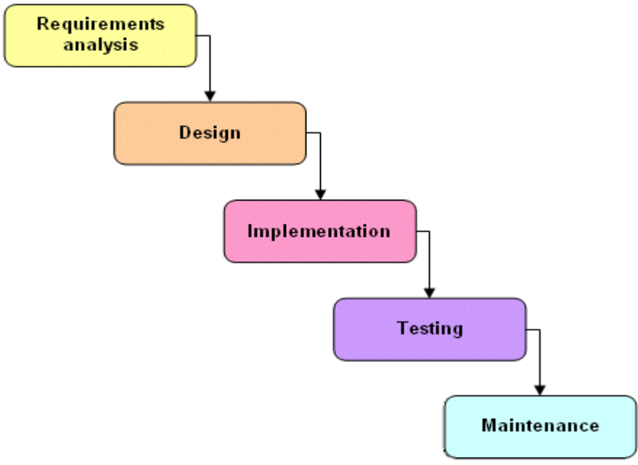
Figure 3.1 waterfall model

3.5 Logical Database Design and Relational Model

Logical Database is a high performance fault tolerance database management system. The database is mostly maintained by Structured Query Language (SQL), which is considered as a heart of database management system. Its popularity is due to case of use, flexibility and capability.
Advantages
- Provides easy access to all data.
- Flexibility in data modeling.
- Reduced data storage and redundancy.
- Independent of physical storage and logical database design.
- Provides a high-level data manipulation language.

3.6 Entity Relationship Diagram

The E-R model is a detailed, logical representation of the data for an organisation or business area. It describes relationship between data abjects. DBA and system analsyt use ERD to perform data modeling and explains the diagram to stakeholders.
Relationship is defined in which way data objects are connected to the other object.
3.6.1 The ER Model
- It is expressed in terms of entities in the business environment, the relationships (or associations) among those entities and the attributes (properties) of both the entities and their relationships
- The E-R model is usually expressed as an E-R diagram
    - Entities used in my project are as given
- Job seeker
js_id
driving_license
gender
email
marital_status
birth_day
visa_type
country
password
picture

JOB SEEKER
first_name
last_name
mobile_no
h_academic
religion

Figure 3.2 job seeker ERD

- Recruiter

employer_id
e_profile
e_contact_mobile
employer_name
password
e_office_locatin
e_city
e_address
Recruiter

e_url
e_email
last_name
e_tel

Figure 3.3 Recruiter ERD

- Admin
admin_id
admin_name
password
Admin

Figure 3.4 Admin ERD

- Post job
job_id
employer_id
salary_range
Post_job
company_name
company_type
salary_method
job_description
gander
age_limit
experience
expiry_date
career_level
commitment
city
industry
job_role
e_city
vacancies

Figure 3.5 Post job ERD

CV
cv_id
js_id
cv_name
cv

cv_original_name
cv_location

Figure 3.6 CV ERD

There are three types of relationship.
3.6.3 One to one relationship:

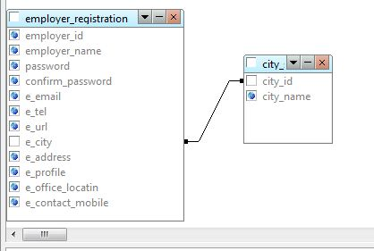
Figure 3.7 One to one relationship

3.6.4 One-to-many relationship:
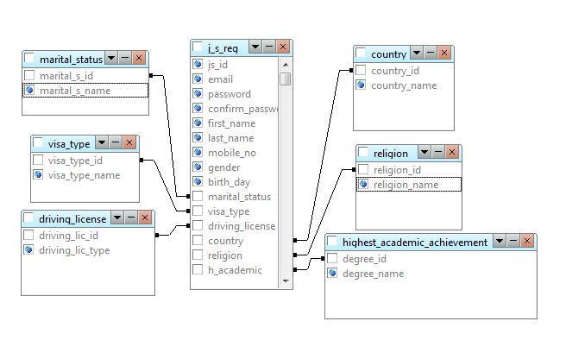
Figure 3.8 One-to-many relationship

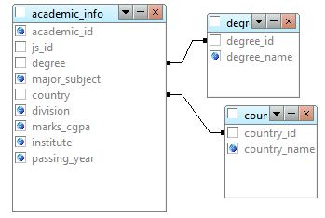
Figure 3.9 One-to-many relationship

3.6.5 Many to Many Relationship:

A relationship in which multiple tables are linked with each other is called many-to-many relationship.
In my project many-to-many relationship does, not exist.
3.7 Control Flow Diagram
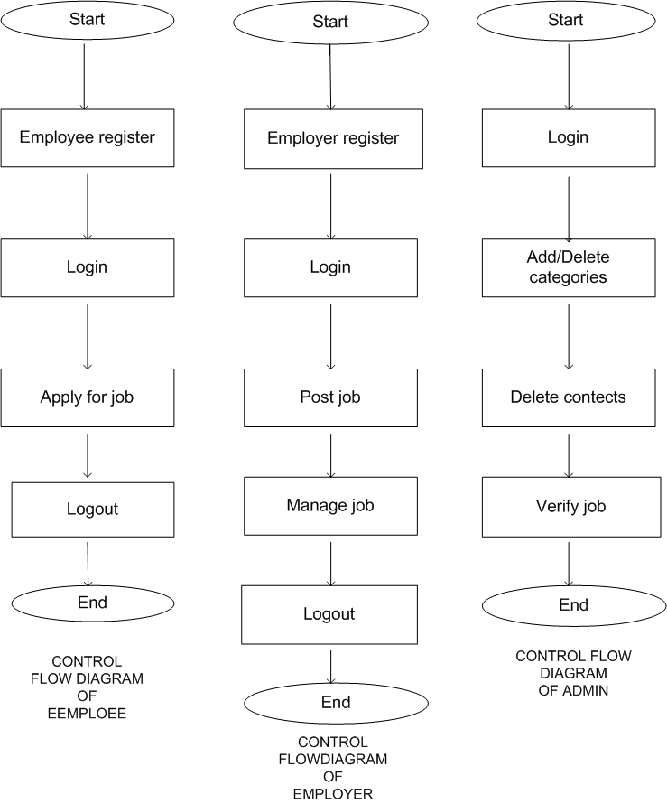
View/delete post
Manage job post
View/delete
Employee/er
Figure 3.10 Control Flow Diagram of project

3.8 UML

UML is a standard language for specifying, visualizing, constructing, and documenting the artifacts of software systems.
- UML stands for Unified Modeling Language.
- UML is different from the other common programming languages like C++, Java, and COBOL etc.
- UML is a pictorial language used to make software blue prints.
So UML can be described as a general purpose visual modeling language to visualize, specify, construct and document software system. Although UML is generally used to model software systems but it is not limited within this boundary. It is also used to model non software systems as well like process flow in a manufacturing unit etc.
UML is not a programming language but tools can be used to generate code in various languages using UML diagrams. UML has a direct relation with object oriented analysis and design. After some standardization UML is become an OMG (Object Management Group) standard.
3.8.1 Use Case diagrams
To model a system the most important aspect is to capture the dynamic behavior. To clarify a bit in details, dynamic behavior means the behavior of the system when it is running /operating.
So only static behavior is not sufficient to model a system rather dynamic behavior is more important than static behavior. In UML there are five diagrams available to model dynamic nature and use case diagram is one of them. Now as we have to discuss that the use case diagram is dynamic in nature there should be some internal or external factors for making the interaction.
These internal and external agents are known as actors. So use case diagrams are consists of actors, use cases and their relationships. The diagram is used to model the system/subsystem of an application. A single use case diagram captures a particular functionality of a system.
So to model the entire system numbers of use case diagrams are used.

Graphical Notation

The basic components of Use Case diagrams are the Actor, the Use Case, and the Association.
Actor | An Actor, as mentioned, is a user of the system, and is depicted using a stick figure. The role of the user is written beneath the icon. Actors are not limited to humans. If a system communicates with another application, and expects input or delivers output, then that application can also be considered an actor. | 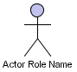
Use Case | A Use Case is functionality provided by the system, typically described as verb + object (e.g. Register Car, Delete User). Use Cases are depicted with an ellipse. The name of the use case is written within the ellipse. | 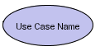
Association | Associations are used to link Actors with Use Cases, and indicate that an Actor participates in the Use Case in some form. Associations are depicted by a line connecting the Actor and the Use Case.
Relationships
Relationships among the use cases and actors
Illustrate relationships between an actor and a use case with a simple line. For relationships among use cases, use arrows labeled either "uses" or "extends." A "uses" relationship indicates that one use case is needed by another in order to perform a task. An "extends" relationship indicates alternative options under a certain use case.

System Boundry Boxes (optional)

A rectangle can be drawn around the use case, called the system boundary box, to indicate the scope of the system. Anything within the box functionality that is in scope and anything outside the box is not. System boundary boxes are rarely used,

Packages (optimal) packages are UML contracts that enable you to organize model element into groups. Packages are depicted as file folders and can be used on any of the UML diagrams including both use case diagrams and class diagrams. Packages are used only when diagrams become unwieldy, which generally implies they cannot printed on a single page to organize a large diagram in to smaller ones.

3.8.2 Activity diagrams

Activity diagram is another important diagram in UML to describe dynamic aspects of the system.
Activity diagram is basically a flow chart to represent the flow form one activity to another activity. The activity can be described as an operation of the system.
So the control flow is drawn from one operation to another. This flow can be sequential, branched or concurrent. Activity diagrams deals with all type of flow control by using different elements like fork, join etc.
Start: each activity diagram has non start (above) at which the sequence of actions begins.
End: each activity diagrams has one finish at which the sequence of actions ends
Activity: are connected tougher by transition. Transitions are directed arrows flowing from the previous activity to the next activity. They are optionally accompanied by a textual label of the form:

Label
The guard is a conditional expression that when true indicates that transition is taken. The label is also optional and freeform.

Activity

To show conditional behavior uses a branch and a merge. The top diamond is a branch and has only one transaction flowing into it and any number of mutually exclusive transitions flowing out. That is the guards on the outgoing transitions must resolve themselves so that only one is followed. The merge is used to end the conditional behavior .there can be any number of incoming and only one outgoing ,transition
To show parallel behavior uses a fork and a join. The fork has one transition entering and any number of transition exiting .all of which will be take. The join represents the end of the parallel behavior and has any number of transitions entering an only one leaving.

3.8.3 State diagram
The name of the diagram itself clarifies the purpose of the diagram and other details. It describes different states of a component in a system. The states are specific to a component/object of a system.
A Statechart diagram describes a state machine. Now to clarify it state machine can be defined as a machine which defines different states of an object and these states are controlled by external or internal events.
Activity diagram explained in next chapter, is a special kind of a Statechart diagram. As Statechart diagram defines states it is used to model lifetime of an object.

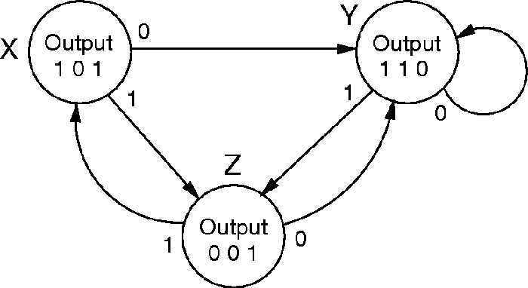
Figure 3.11 state diagram ERD

States are represented as a rounded rectangle with the name of the state shown. Optionally you can include an activity that represented a longer running task during that state. Connecting states together are transitions. These represented the events that cause the object to change from one state to another. The guard clause of the label is again mutually exclusive and must resolve itself to be either true or false. Actions represent tasks that run causing the transitions actions are

different from activates in that action cannot be interrupted, while an activity can be interrupted by and incoming event .both ultimately represent and operation on the object being studied. For example an operation that sets an attribute would be considered and action, while a long calculations might be an activity. The specific separation between the two depends on the object and the system being studied. Like activity diagrams state diagrams, state diagram have one start and one end format which the state transitions start and end respectively.

3.8.4 Sequence diagrams

Sequence diagrams are used to show the flow of functionality through a use case. Actors and objects are shown at the top of the diagram. Each arrow represents a message passed between actor and object to or object and object to perform the needed functionality .it depicts the objects and classes involved in the scenario and the sequence of messages exchanged between the object needed to carry out the functionality of scenario.
Sequence diagrams describe interaction among class in terms of an exchange of messages over time.

Basic sequence diagram symbols and notations class roles

Class roles describe the way an object will behave in context. Use the UML object symbol to illustrate class roles, but don’t list object attributes.

Object | Objects are instances of classes, and are arranged horizontally. The pictorial representation for an Object is a class (a rectangle) with the name prefixed by the object name (optional) and a semi-colon. | 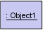
Actor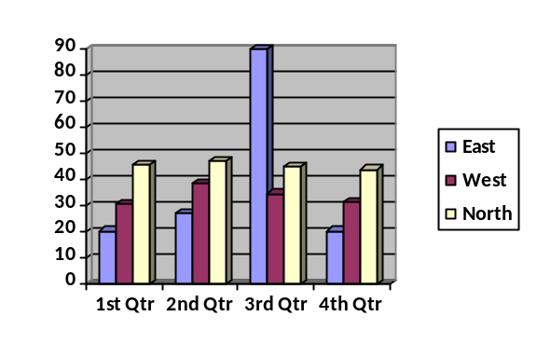 | Actors can also communicate with objects, so they too can be listed as a column. An Actor is modeled using the ubiquitous symbol, the stick figure. | 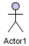
Lifeline | The Lifeline identifies the existence of the object over time. The notation for a Lifeline is a vertical dotted line extending from an object.
Activation | Activations, modeled as rectangular boxes on the lifeline, indicate when the object is performing an action.
Message | Messages, modeled as horizontal arrows between Activations, indicate the communications between  Objects.
Loops

A repetition or loop within a sequence diagram is depicted as a rectangle .Place the condition for exiting the loop at the bottom left corner in square brackets [].
3.9 Use Case Diagram of System

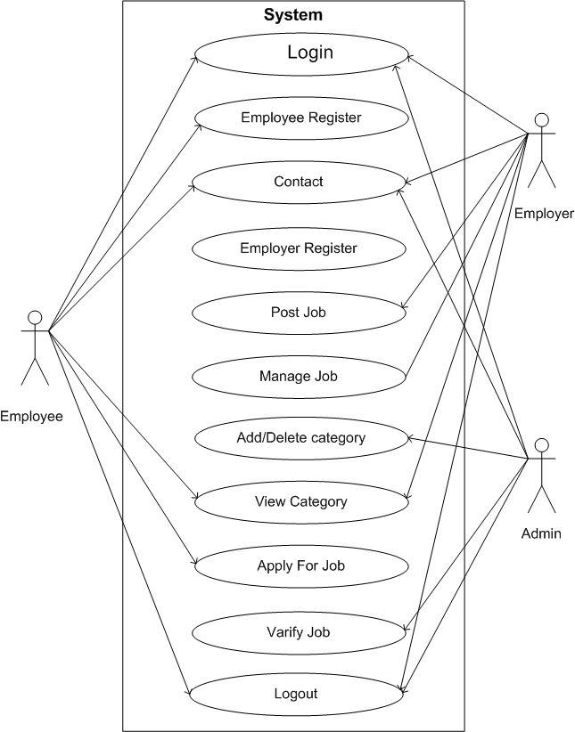
Figure 3.12 Use Case Diagram of System

3.10 Use Case Diagram for Job seekers

Sign up

Visit site

View jobs

Search jobs

User/Job seeker
Apply for job

View NEWS Figure 3.13 Use Case Diagram for job seekers

Sign out

Use Case Diagram for Recruiters

Sign Up

Visit site

Add jobs

View posted Jobs

View applicants

View profile

Company/Employer

Edit profile

Figure 3.14 Use Case Diagram for recruiters

Sign out

Use Case Diagram for Admin

Log in Registered User

Sign Up

View user

Delete user

View Company

Delete Company
View jobs
Company/Employer
Delete jobs
Figure 3.15 Use Case Diagram for Admin

Sign Out

Use Cases for job seeker

Use Case for Visit site

User Visit Site

Name | Visit Site
Description | This Use case is used when user wants to visits the site and wants to get the Information about the companies that are providing the jobs. And view the opportunities to Apply.
Precondition | The Keyword for the site must be entered carefully.
Primary Flow | When User opens the site (Main Page) All Information Affiliated with the site) is displayed to the user.  Total no of jobs in different industries is displayed
Post Condition: | On Demand the required page is displayed.

Use Case of Sign Up

User Sign Up

Name | Sign Up
Description: | This Use case is used when user is wants to sign up and wants to be registered. Because to apply for a job.
Precondition | The keyword for the site must be opened.
Primary Flow | When user is new to the site and to get benefit from the site, user wants to be registered then he/she opens the registration form.  User Fills this form. User gives all necessary information which is required.  After completing this form, user submits this form and Gets registered.
Post Condition: | User is registered to the site and becomes an authorized user.

Use case for View Jobs

User View jobs
Name: | View Jobs
Description | This Use Case is used when user wants to view job of multiple categories. User start view for the required Job.
Precondition | The User must click on the link Current Jobs for finding required job. He/She may also see the jobs of different countries.
Primary Flow | When user clicks on the current jobs.  All related/required jobs are retrieved and displayed.  User Selects the required job.  The detailed Information about the job and job offering company is displayed.
Post Condition: | All related and vacant jobs are displayed to the user.

Use case for Searching Jobs

User Search for job

Name: | Search for Job
Description | This Use Case is used when user wants to search for a specific job and wants to apply for that job. User start search for the required Job.
Precondition | The User must write the title of specific job in a box and then click on button Search for job.
Primary Flow | When user clicks on the search for jobs.  All related/required jobs according to search command are retrieved and displayed.  All detailed Information about the job and the job offering company is also displayed.  User Selects the required job.  The detailed Information about the job and job offering company is displayed.
Post Condition: | All related and vacant jobs are displayed to the user.

Use Case to Apply for Job

User Apply for Job

Name | Apply for Job
Description: | This use case is used when user wants to apply for a job. User has to submit his application form.
Precondition: | The user must Sign in or Register to apply and then the User must click on the link Apply for applying specific job.
Primary Flow | After filling the provided application form, user wants to apply for job.  User selects a required job.  User submits his/her application for that job.
Post Condition | After validating the user’s information given in application. User is given response.

Sequence Diagrams for Job seeker

Sequence Diagram of Use Case Visit Site

SITE MAIN PAGE
VISIT PAGES
User

REQUEST URL

VISIT SITE

EXIT

Figure 3.16 Sequence Diagrams for Job seeker

Sequence Diagram of Use case Sign Up

SITE MAIN PAGE
MEMBERSHIP
USER MAIN PAGE
WEB SERVER
USER

REQUEST URL

SIGN UP

PROMOT FOR INPUT

SUBMIT DATA

SUBMIT

PROMPT

Figure 3.17 Sequence Diagram of Sign Up

Sequence Diagram of Use Case View jobs

SITE MAIN PAGE
Current jobs list page
WEB SERVER
User

REQUEST URL

Current jobs

Jobs Query

Exit

Figure 3.18 Sequence Diagram of View jobs

Activity Diagram for Job seeker
Activity Diagram for Visit Site Use Case

Site Main pages
Display Visit page
Select Visit site

Figure 3.19 Activity Diagram for Visit Site

Activity Diagram for Sign Up

Save information
Submit Data
Input Data
Display Form
Select Apply
For Job
Site Main page

Figure 3.20 Activity Diagram for Sign Up

Activity Diagram for View Jobs Use Case
Site main page

Display Error

Display List

Select Job
Illegal
Request

Figure 3.21 Activity Diagram for View Jobs
Use Cases for Company
Use Case for Visit Site

Company Visit Site

Name | Visit Site
Description: | This Use Case is used when company is seeking for an online portal to place their site and wants to visits this site.
Precondition: | The keyword for the site must be entered carefully.
Primary Flow | When company opens the site (Main Page) All Information Affiliated with the site is retrieved from the Database and displayed to the user.
Post Condition: | On Demand the required page is displayed.

Use Cases for Sign Up

Company Sign Up

Name | Sign Up
Description: | This use case is used when company is not registered and wants to be registered. Because to place a job, company must be registered to the site.
Precondition: | The keyword for the site must be entered carefully and registration form must be opened.
Primary Flow | When company is new to the site and to place its jobs, company wants to be registered then its opens the registration form company fills this form. And gives all necessary information which is required. After completing this form, it submits this form and Gets registered.
Post Condition: | Company is registered to the site and becomes and authorized user.

Use case for View Applicants

User View applicants

Name: | View applicants
Description | This Use Case is used when user wants to view applicants of a specific job. User start view for the required applicant.
Precondition | The User must click on the link APPLICANTS for finding required applicant. Employer may also see the profile of applicant.
Primary Flow | When user clicks on the applicants.  All related/required applicants are retrieved and displayed.  All detailed Information about the applicant is also displayed.  User Selects the required applicant detail  The detailed Information about the applicant is displayed.
Post Condition: | All related and applicants are displayed to the user.

Activity Diagram for Sign Up

Save
Information
Submit Data
Input Data
Display Form
Select new user
Site Main
Page

Figure 3.22 Activity Diagram for Sign Up

Activity Diagram for View applicants Use Case
Employer Main
Page
Display Applicants list
Select View applicants

Figure 3.23 Activity Diagram for View applicants

Activity Diagram for Post Jobs Use Case

Admin Main
Page

Ask for Data

Select Post job

View jobs
Job

Select Save

Figure 3.24 Activity Diagram for Post Jobs
Activity Diagram for Edit Information Use Case

User Main
Page

Input data

Display
Information

Select
Edit/Update

Select View
Page

Save Query

Figure 3.25 Activity Diagram for Edit Information
Activity Diagram for Delete Information Use Case

User Main
Page

Select View
Page

Display
Information

Select
DELETE

Save Query

Figure 3.26 Activity Diagram for Delete Information

3.11 Database Design

Tables

As a result, the System, Online jobs seeking uses a number of database files. The database is a collection of interrelated data about an enterprise with multiple users. The project, online jobs seeking, includes the following database files:

Over all Database View:

Here all Tables of Database Are Visible.

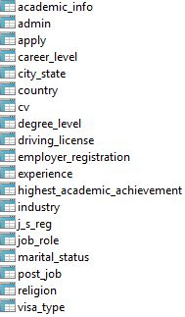

Figure 3.27 Over all Database
Table Name: academic_info
Primary key:academic_id
Description:
This table is used to keep record of job seeker academic qualification.

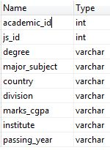
Figure 3.28 academic_info

Table Name: apply
Primary key:apply_id
Description:
This table is used to keep the information of each user and each job for which a registered applicant/job seeker has applied.

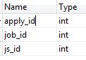
Figure 3.29 apply

Table Name: career_level
Primary key: career_id
Description:
This table is used to keep the information whether the required applicant for a job should be is intern, Student, Fresh, Experienced, Officer, Manager etc.

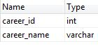
Figure 3.30 career_level

Table Name: city_state
Primary key: city_id
Description:
This table is used to keep the information that in which city or state of UAE job is available.
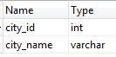
Figure 3.31 city_state

Table Name: country
Primary key: country_id
Description:
This table is used to keep the information from which country the job seeker belongs
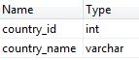
Figure 3.32 country

Table name: cv
Primary key:cv_id
Description:
This table is used to keep the CV of job seeker with association of its js_id

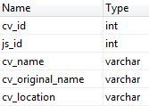
Figure 3.33 cv

Table name: degree_level
Primary key:degree_id
Description:
This table is used to keep information about job seeker degree level.

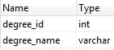
Figure 3.34 degree_level

Table name: driving_license
Primary key: driving_license_id
Description:
This table is used to keep information about job seeker driving license because there are many companies in UAE which give allowance who have driving license of UAE.

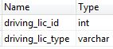

Figure 3.35 driving_license

Table name: employer_registration
Primary key: employer_id
Description:
This table is used to keep information about employer. Employer can registered him to post job.

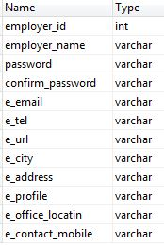

Figure 3.36 employer_registration

Table name: experience
Primary key: experience_id
Description:
This table is used to take information about job seeker’s experience in his relevant applied post/job

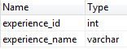

Figure 3.37 experience

Table name: highest_academic_achievement
Primary key:degree_id
Description:
This table is used to take information about job seeker’s highest qualification.

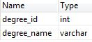

Figure 3.38 highest_academic_achievement

Table name: industry
Primary key:industry_id
Description:
This table is used to take information about different types of industries. In which job seekers can apply for job according to their related interested industry

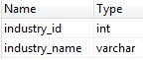

Figure 3.39 industry

Table name: j_s_reg
Primary key:js_id
Description:
This table is used to take information about job seeker after fulfill this table the job seeker becomes member of jobs UAE and can apply for jobs.

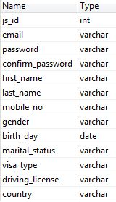

Figure 3.40 j_s_reg

Table name: job_role
Primary key:job_id
Description:
This table is used to take information about job role. Which specifies job role on that job seeker apply.

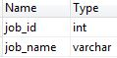

Figure 3.41 job_role

Table name: marital_status
Primary key: marital_s_id
Description:
This table is used to take information about job seeker marital status.

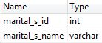

Figure 3.42 marital_status

Table name: post_job
Primary key:job_id
Description:
This table is used to take necessary information before post any job. Job seeker can apply any job by getting information with the help of this table.

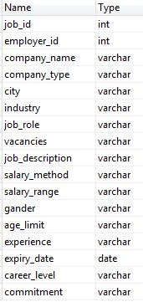

Figure 3.43 post_job

Table name: religion
Primary key: religion_id
Description:
This table is used to take information about religious beliefs of job seeker because in UAE its international market so it’s n necessary to know about job seeker religious beliefs.

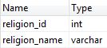

Figure 3.44 religion

Table name: visa_type
Primary key: visa_type_id
Description:
This table is used to take information about visa type of job seeker.

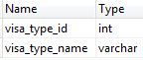

Figure 3.45 visa_type
Table name: Admin
Primary key:admin_id
Description:
This table is used by admin.
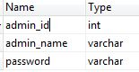

Figure 3.46 Admin

